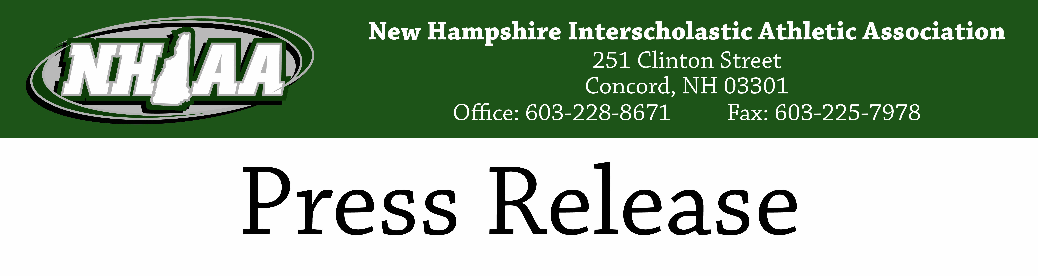
For Immediate Release
March 23rd, 2020
RE: NHIAA Championships

By unanimous vote, the NHIAA Executive Council has enacted a resolution in order to fulfill its duties with regard to the awarding of State Champion and Runner-Up plaques and medals to teams participating in tournaments cut short by the COVID-19 pandemic. Co-Champions will be awarded to the highest seeded team remaining on each side of the NHIAA Tournament bracket. All other teams remaining in the tournament will be awarded Runner-Up plaques and medals.

While most wish the tournaments could have been concluded in their normal fashion, this compromise solution takes into account the regular season and a team’s progress through the tournament prior to the suspension of play. We hope that this solution will bring some closure to the NHIAA winter season. Congratulations to the following teams:

Ice Hockey
Girls Ice Hockey  Champions - Concord and Berlin-Gorham | Division I Boys Ice Hockey  Champions - Concord and Bedford
Division II Boys Ice Hockey  Champions - Keene and St. Thomas | Division III Boys Ice Hockey  Champions - Berlin-Gorham and Kennett

Boys Basketball
Division I Boys Basketball  Champions - Exeter and Portsmouth  Runner-Up - Nashua South, Salem, Keene, Alvirne, Nashua North, Merrimack | Division II Boys Basketball  Champions - ConVal and Bow  Runner-Up - Oyster River, Hollis Brookline, Hanover, Kennett, Pelham, Lebanon
Division III Boys Basketball  Champions - Gilford and Mascenic | Division IV Boys Basketball  Champions - Littleton and Newmarket

Girls Basketball
Division I Girls Basketball  Champions - Bishop Guertin and Goffstown  Runner-Up - Bedford and Londonderry | Division II Girls Basketball  Champions - Lebanon and Spaulding

Unified Basketball
Champions - Berlin and Exeter
Runner-Up - Londonderry and Dover

In addition to the actions taken above, the NHIAA Executive Council unanimously approved the use of the scores earned in the preliminary round of the Winter Spirit competition to declare a Champion and Runner-Up for the 2020 Winter Spirit Championships. Congratulations to the following schools:

Winter Spirit:
Division I Spirit  Champion - Pinkerton  Runner-Up - Dover | Division II Spirit  Champion - Pembroke  Runner-Up - Pelham | Division III Spirit  Champion - Littleton  Runner-Up - Mascenic

Contact:
Jeffrey Collins
Executive Director
(603) 228-8671

